1. Write a C code to check if a 3 x 3 matrix is invertible. A matrix is not invertible if its determinant is 0.

Ans:

#include<stdio.h>

int main()

{

int a[3][3], i, j;

long determinant;

// 9 elements of matrix is taken as input from test data

for(i = 0 ; i < 3; i++)

for(j = 0; j < 3; j++)

scanf("%d", &a[i][j]);

/*Use the printf statements as:

printf("The given matrix is not invertible");

printf("The given matrix is invertible");

*/

determinant = a[0][0] * ((a[1][1]*a[2][2]) - (a[2][1]*a[1][2])) -a[0][1]*((a[1][0]* a[2][2]) - a[2][0] * a[1][2]) + a[0][2] * ((a[1][0] * a[2][1] - a[2][0]*a[1][1]));

if ( determinant == 0)

printf("The given matrix is not invertible");

else

printf("The given matrix is invertible");

return 0;

}

1. Write a C program to sort a 1D array using pointer by applying Bubble sort technique.

|  |  |  |  |  |
| --- | --- | --- | --- | --- |
| **Private Test cases used for evaluation** | **Input** | **Expected Output** | **Actual Output** | **Status** |
| Test Case 1 | 7  70  40  80  10  200  30  60 | 10\n  30\n  40\n  60\n  70\n  80\n  200 | 10\n  30\n  40\n  60\n  70\n  80\n  200\n | Passed |

#include<stdio.h>

void sort(int *a, int n);

int main()

{

int a[20];

int n,i;

scanf("%d",&n); // Enter number of elements to sort is taken from test case data

for(i=0;i<n;i++)

{

scanf("%d",&a[i]); // The elements of the array is taken from the test data

}

sort(a, n); // Calling the sorting function

//Printing the sorted array

for(i=0;i<n;i++)

{

printf("%d\n",a[i]);

}

return 0;

}

void sort(int *a, int n)

{

int i,temp,j;

for(i=1;i<n;i++)

{

for(j=0;j<n-i;j++)

{

if(*(a+j)>=*(a+j+1))

{

temp = *(a+j);

*(a+j)= *(a+j+1);

*(a+j+1)= temp;

}

}

}

}

1. Write a C program to sort a given 1D array using pointer in ascending order.

|  |  |  |  |  |
| --- | --- | --- | --- | --- |
| **Private Test cases used for evaluation** | **Input** | **Expected Output** | **Actual Output** | **Status** |
| Test Case 1 | 8  90  70  30  -10  -40  20  100  50 | -40\n  -10\n  20\n  30\n  50\n  70\n  90\n  100 | -40\n  -10\n  20\n  30\n  50\n  70\n  90\n  100\n | Passed |

#include <stdio.h>

int main()

{

int a[100],i, n;

scanf("%d",&n); //Number of elements of the array is taken from the test case data

for (i=0; i<n; i++)

{

scanf("%d",a+i); // Input the array elements

}

int j,t;

for (i=0; i<(n-1); i++)

{

for (j=i+1; j<n; j++)

{

if (*(a+i)>*(a+j))

{

t=*(a+i);

*(a+i)=*(a+j);

*(a+j)=t;

}

}

}

// Printing sorted array in ascending order

for (i=0; i<n; i++)

{

printf("%d\n",*(a+i));

}

return 0;

}

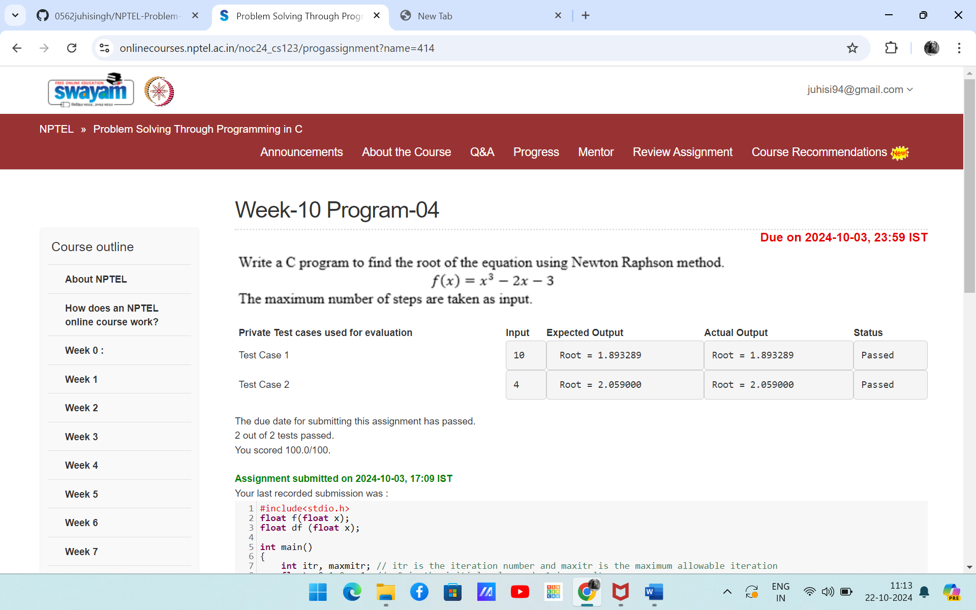

#include<stdio.h>

float f(float x);

float df (float x);

int main()

{

int itr, maxmitr; // itr is the iteration number and maxitr is the maximum allowable iteration

float x0=1.0, x1; // x0 is the initial value and x1 is result

scanf("%d", &maxmitr); // Taken from the test cases

// use the printf statement as printf("Root = %8.6f\n", x1);

float h;

for (itr=1; itr<=maxmitr; itr++)

{

h=f(x0)/df(x0);

x1=x0-h;

x0=x1;

}

printf("Root = %8.6f", x1);

return 0;

}

float f(float x)

{

return x*x*x - 2*x - 3;

}

float df (float x)

{

return 3*x*x-2;

}